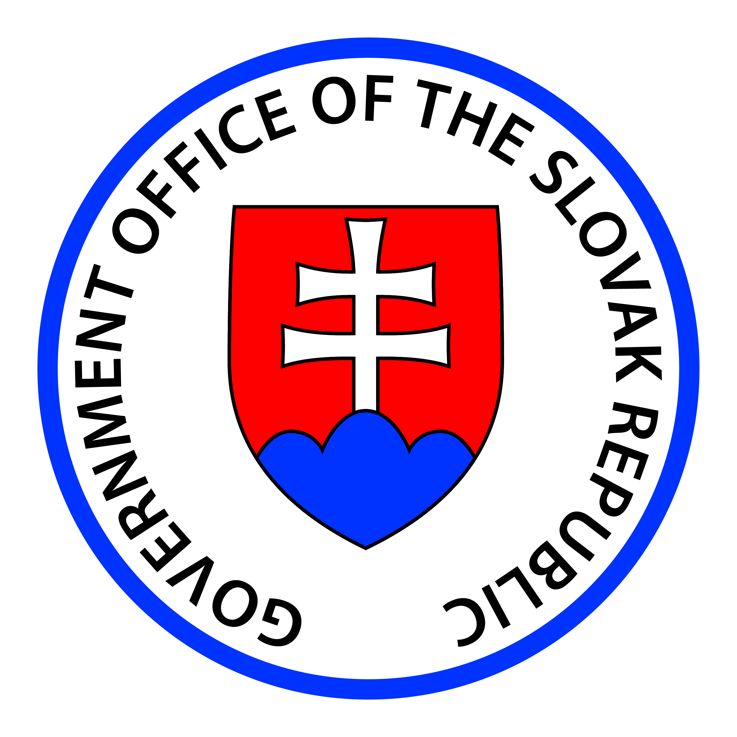
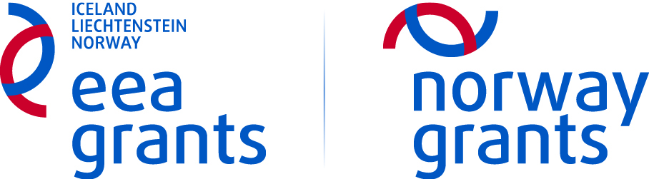

GRANT APPLICATION

Bilateral Fund at National Level for 2016

National Focal Point  Office of Government of the Slovak Republic  EEA and Norway Grants Dept.  Strategic Action unit  Námestie slobody 1  813 70 Bratislava, Slovak Republic | In case of questions please contact bilateralnyfond@vlada.gov.sk  alebo / or  +421 2 20925 574
Applicant:
Thematic component: ( choose the option)
Short specification of the activity for the purposes of reporting and publicity

Instruction for completing the Grant Application:

- The Grant Application is divided into two basic parts – part I. (to be filled by applicant – page 2 - 10) and part II. (to be filled by NFP and Bilateral Commission).
- Obligatory parts common to all activities are marked by green label ●
- Optional parts common to all activities are marked by brown label ●
Obligatory parts relevant for concrete activities are marked by red label ● with specification of type of eligible activity.
- The scope of data listed in the Grant Application is determined by applicant´s decision and NFP accepts the difference within the range of provided data depending on type of activity (e.g. briefer description within implementation of activity „participation at event“).
- If it is necessary to exceed the scope of the data field, use your own attachment with reference to the field

● Grant Application Version
Draft (to be submitted electronically only)
Final version (to be submitted by mail)

● 1. Type of eligible activity (choose the option)

● 2. Bilateral Activity Title
2.1 Full name

2.2 Short working name

● 3. Information about the applicant
3.1 Full legal name |  |  | 3.2 Organisation ID number
3.3 Address | 3.4 Postal code | 3.5 City |  | 3.6 Country  Slovak Republic
3.7 Telephone | 3.8 Email |  |  | 3.9 Website
3.10 Contact person | 3.11 Contact person email |  |  | 3.12 Mobile phone number
3.13 Bank account - IBAN: |  |  |  | 3.14 Bank code / SWIFT:
3.15 Legal Form of the organisation

3.16 How did you learn about the availability of the grant? (choose the option)
Others:
3.17 Brief description of applicant

3.18 Description of relevant activities, experiences of applicant which have been carried out in relevant thematic area within period min. 1 year before submission of Grant Application.

4. Information about the partners
● 4.1 Partner 1 - Financial Participation: (choose the option)
4.1.1 Full legal name |  |  | 4.1.2 Organisation ID number
4.1.3 Address |  | 4.1.4 Postal code |  | 4.1.5 City |  | 4.1.6 Country
4.1.7 Telephone |  | 4.1.8 Email |  |  | 4.1.9 Website
4.1.10 Contact person | 4.1.11 Contact person email |  |  |  | 4.1.12 Mobile phone number
4.1.13 Bank account - IBAN: |  |  |  |  | 4.1.14 Bank code / SWIFT:
4.1.15 Type of organisation (choose the option)

NOTE: In case of partner “international organisation” it is required also partner from donor states.
4.1.16 Legal Form of the organisation:

4.1.17 Brief description of partner 1:

4.1.18 Description of relevant activities, experiences of partner which have been carried out in relevant thematic area within period min. 1 year before submission of Grant Application. (only for partners with financial participation)

● 4.2 Partner 2 – Without financial participation
4.2.1 Full legal name |  |  | 4.2.2 Organisation ID number
4.2.3 Address |  | 4.2.4 Postal code |  | 4.2.5 City |  | 4.2.6 Country
4.2.7 Telephone |  | 4.2.8 Email |  |  | 4.2.9 Website
4.2.10 Contact person | 4.2.11 Contact person email |  |  |  | 4.2.12 Mobile phone number
4.2.13 Type of organisation (choose the option)

NOTE: In case of partner “international organisation” it is required also partner from donor states.
4.2.14 Legal Form of the organisation:

4.2.15 Brief description of partner 2:

● 4.3 Partner 3 –Without financial participation
4.3.1 Full legal name |  |  | 4.3.2 Organisation ID number
4.3.3 Address |  | 4.3.4 Postal code |  | 4.3.5 City |  | 4.3.6 Country
4.3.7 Telephone |  | 4.3.8 Email |  |  | 4.3.9 Website
4.3.10 Contact person | 4.3.11 Contact person email |  |  |  | 4.3.12 Mobile phone number
4.3.13 Type of organisation (choose the option)

NOTE: In case of partner “international organisation” it is required also partner from donor states.
4.3.14 Legal Form of the organisation:

4.3.15 Brief description of partner 2:

● 5. Activity Proposal
5.1 Location of activity implementation: (choose the option)
5.2 Date, period of activity implementation:
5.3 Time schedule of proposed activity ( tick the box)

Start of activity implementation :
Finalisation of activity implementation (expected exact date):

Comment:

● 5.4 Description of the proposed bilateral activity
Descripe the bilateral activity in detail.

● 5.5 Objective of activity
Choose and describe one objective of the activity in the context of strengthening bilateral relations and specify the relationship of the activity towards strengthening bilateral relations. How will the proposed activity contribute to achieving the goal in the specific topic? At the same time describe in detail contribution and target value of activity implementation in particular thematic area (component).
5.5.1 Choose predefined objective (tick one box)

To develop and strengthen existing bilateral relations between Slovak Republic and donor states

To create new ties and opportunities for cooperation with regard to sustainable cooperation

To promote the bilateral dimension of the implementation of the EEA and Norway Grants.

Description:

● 5.6 Groups of results (choose the option)
Choose one group of results and explain the contribution to the particular types of results, for more information see Guideline for Strenghtened bilateral relations, p. 6-7 ). In part 5.7.1 name at least one indicator and assign a respectvive value in part 5.6.2.and 5.6.3. Examples of result indicators are shown below.
5.6.1 Indicator - Result | 5.6.2 Initial Value | 5.6.3 Target Value

Examples of bilateral results indicators
Group of results | Indicator - Result | Indicator
1. Extend of cooperation | Partnership Agreement signed | Number
1. Extend of cooperation | Number of women involved to activity implementation | Number
1. Extend of cooperation | Number of men involved to activity implementation | Number
1. Extend of cooperation | Number of involved experts | Number
2. Shared results | New policies, laws and regulations adapted, as a result of bilateral cooperation | Number
2. Shared results | Joint arcitles published in a national or international periodicals / magazines | Number
2. Shared results | New Technologies /practises/concepts as a result of transfer of knowledge | Number
2. Shared results | Joint publications / textbooks as results of bilateral cooperation | Number
3. Knowledge and mutual understanding | Number of articles published in one country about the other country | Number
3. Knowledge and mutual understanding | Improved information capacity of target groups about both countries | Enquiry
3. Knowledge and mutual understanding | Improved knowledges about the EEA and Norway Grants | Enquiry
4. Wider effects | Proffesional / Scientistic / Cultural networks established | Number
4. Wider effects | Joint initiatives in relevant area | Number

● 5.Additional outcomes of the activity beyond the predefined outcomes stated in Annex No. 3 of the Announcement
If neccessary set and describe additional expected outcome (s) of the activity (beyond the predefined outcomes in Annex 3 of the Announcement.

Description:

● 5.8 Description of target groups
Only in case of implementation activity „Organisation of event“.

● 5.9 Short publicity plan
Only in case of implementation activity „Organisation of event“.
A Publicity Plan is required to be prepared with the aim of raising awareness of the activity with focus on presentation of bilateral activity, dealing with media etc.

● 5.10 Horizontal Objectives (tick the box)
Choose at least one horizontal objective and briefly describe how to to achieve this objective.
Fight against hate speech and extremism
Fight against homophobia
Fight against racism and xenophobia
Fight against violence against women / children
Support of cultural dialogue between social and ethnic groups
Support of multicultural / intercultural understanding
Support of social inclusion with significant respect on Roma inclusion
Support of sustainable development
Support of knowledge society
Support of tolerance

Description:

● 6. Estimated costs
Total Eligible Costs |  |  |  |  |  |  |  | Total (EUR)
Amount of expenditures implemented by Applicant:
Amount of expenditures implemented by Partner with financial participation:
Expenditures breakdown –page 1
Type of expenditure |  | Unit | Unit price (EUR) | Number of units | Specification * | Sub-item procurement | Notes - explanations* | Amount  (EUR) | Implement
1.
2.
3.
4.
5.
6.
7.
8.
9.
10.
11.
12.
13.
14.

Expenditures breakdown –page 2
Type of expenditure |  | Unit | Unit price (EUR) | Number of units | Specification * | Sub-item procurement | Notes - explanations* | Amount  (EUR) | Implement
15.
16.
17.
18.
19.
20.
21.
22.
23.
24.
25.
26.
27.
28.
29.
30.

● 7. Attachments
Attachment |  | Status | Brief description
Statement of the organisation certifying the legal status of partner from a donor state, or an international organisation with financial participation |  | Mandatory attachment in the case of donor partner, or an international organisation with financial participation
The list, description and analysis of expectations for future after finalisation of activity implementation with emphasis to further / ongoing development of bilateral cooperation |  | Mandatory attachment
Draft Partnership Agreement |  | In case of partner with financial participantion
Program / Program proposal |  | Mandatory attachment
Invitation |  | If applicable
Public procurement procedures description |  | If applicable
Other:
Other:
Other:
8. Statements, date and signature
By the signature of this Grant Application:
- I hereby declare, that I am eligible to sign this document and I declare that the information in this document are correct;
- I hereby declare, that all information provided in the application together with attachments are complete and accurate;
- In case the Grant Application is approved Decision of the NFP on the approval of the Grant Application will be accepted, I am obliged to implement the activity in accordance with the Announcement on the opening of the Bilateral Fund at National Level, Grant Application and with the Decision of the NFP on the approval of the Grant Application;
- I hereby declare that I am aware of all conditions related to the grant provision and I am obliged to comply with them;
- I am obliged to return all unlawfuly disbursed payments in accordance with relevant legislation;
- I agree with the dissemination and use of my personal data submitted in the application and its attachments for the purpose of proccessing my application for the grant regulated by the Act No. 122/2013 Coll. from 30 April 2013 on the privacy of personal data and permission for their use to the third party in accordance to § 9 Section 2 Act No. 122/2013 Coll.;
- I agree that the data specified in the application can be used for statistical purposes and for monitoring, reporting and evaluation;
- I am aware of my legal and/ or criminal liability and the obligation to repay the funds allocated after providing false/ misleading information to comply with conditions of funding.
- I hereby declare, that legal entity which I represent has no tax deficiency;
- I hereby declare, that legal entity which I represent is not the subject of bankruptcy proceedings, the restructuring proceeding and the petition for bankruptcy against it has not been dismissed due to lack of assets;
- I hereby declare, that against the legal entity which I represent there is no writ of execution;
- I hereby declare, that legal entity which I represent did not breach the prohibition of illegal work and illegal employment under special regulations,
- I hereby declare, that legal entity which I represent are no outstanding liabilities in the payment on health insurance, social insurance contributions and pension insurance.

Place and date: | Name and signature of Statutory representative  (relevant only if it is a final version):

PART II
Assessment of the Grant Application

STEP 1: Initial assessment by NFP

Summary information
1.1 Verification of formal criteria
1. | Has the Grant Application been submitted in relevant period?
2. | Has the Application been submitted at least 30 working days prior to the planned start of activity implementation?
3. | Has the Application been submitted by email on bilateralnyfond@vlada.gov.sk?
4. | Has the Grant Application form been submitted in relevant format?
5. | Is in the Grant Application listed partner from donor state with financial participation and / or without financial participation
6. | Has the statement from the organisation register certifying the legal status partner from a donor state with financial participation been submitted?
7. | Applicant meets formal elegibility critera.
8. | Partner with financial participation meets formal eligibility criteria
9. | Has the mandatory attachment „The list, description and analysis of expectations for future after finalisation of activity implementation with emphasis to further / ongoing development of bilateral cooperation“ been submitted?
10. | Has the Applicant submitted only one Grant Application within the announcement?
Comment:

The Grant Application met all formal criteria if all points are marked as „YES“. The exception are only point 6., 8. which can be marked "N/A" in case of activity implementation without partner with financial participation. In case that any point is marked as „NIE / NO“, Grant Application will be rejected within initial assessment
1.2 Verification of substantive criteria
 | Applicant´s eligibility verification
1. | Have been sufficiently demonstrated experiences of the Applicant within the relevant thematic areaat least 1 year?
2. | Have been sufficiently demonstrated experiences of the partner with financial participation within the relevant thematic area at least 1 year?
 | Grant application completness
3. | Applicant has filled out all relevant fields and submitted all relevant attachments listed in Part I., point 7 - Attachments?
4. | Proposal is clearly structured, respective parts of the activity are interconnected and logically planned
5. | The overall data compliance
 | Eligibility of Activity Implementation
6. | Activity eligibility
7. | Eligible period
8. | Is the activity planned for implementation within eligible area?
9. | Clear contribution to strenghtening bilateral relations
10. | Contribution to the thematic area
11. | Are activity, objectives, outomes, groups of results correctly and properly described?
12. | Activity proposal clearly supports the objective
13. | Time planning is feasible and effective
 | Budget
14. | The expenses amount compliance with announcement
15. | Indicated Expenses Eligibility
Comment:

During the process of initial substantive assessment may the NFP ask for additional documentation, explanation or information necessary to initial assessment of fulfilment of substantive eligibility criteria. The Grant Applicantion fulfil all substantive criteria within initial assessment if all points are marked as „YES“ and Grant Application will be recommended to further assessment within Bilateral Commission. In case of mark four and more point as „NIE / NO“ NFP will propose Billateral Commission to reject the Grant Apllication.

1.3 Financial coverage
1. | Available fund amount
2. | Grant Application added to reserve list
Comment:

In case the answer in point 1 is „No“ the Grant Application will be suspended and added to reserve list.

3. Limits and financial data – ( to be filled only in
case of answer „NIE/NO“ in part 1.2, point 14 and 15)
3.1 Reduction of expected amount total:

3.2 Describe the reasons for reduction: | Within specific part: | Amount reduction | Total
3.2 Describe the reasons for reduction: | Total eligible expected costs
  - Comment:

4. Preliminary statement (result of initial assessment)

Recommnedation to further assessment within Bilateral Commission

CONSENT

Recommnedation to reject the Grant Application within Bilateral Commission

DISSENSION
Rejection (formal criteria) |  | Reasons:
Suspension |  | Reasons:
Funds reserved on:
Date of submission of the GA to the Bilateral commission
Comment:

5.Date and signature
Place and date | Name and signature

STEP 2: Assessment by Bilateral Commission

- Statement –

1.1 Verification
Verification of partner with financial participation
The partner with financial participation is a suitable institution
Description and justification of Grant Application |  | Number of points | Values
Activity proposal clearly supports the strenghtening of bilateral relations and is in compliance to objective stated in the Grant Application and sustainability of bilateral cooperation in future is proved. |  |  | 0-40
Proposal is clearly structured, respecitive parts of activity are interconnected and logically planned and achievement of outcomes and results is expected |  |  | 0-10
How the proposed activity reflects the chosen horizontal objectives? |  |  | 0-5
Time planning is feasible and effective |  |  | 0-5
Budget and limits
The proposed budget is in compliance with the proposed activity |  |  | 0-10
Contribution to the thematic area (component)
The proposed activity is a contribution in the thematic area (component) |  |  | 0-30
Number of points |  |  | 0-100
The Grant Application is recommended if has achieved minimum 75 points and aswer on question in part 1.1 is „yes“
1.2 Statement
GA recommended for approval within Final Assessment
GA not recommended for approval within Final Assessment
1.3 Justification of the decision

1.4 Date and signature
Place and date | Name and signature

STEP 3: Final assessment by NFP

Conclusion of the by Bilateral Commission
Statements: | GA recommended for approval within Final Assessment | GA not recommended for approval within Final Assessment | GA returned on initial assessment
Royal Norwegian Embassy in Bratislava
Ministry of Foreign and European Affairs of SR
Office of the Government of the SR – National Focal Point
Summary:
Comment:

Decision of NFP
Approval |  | Total approved amount:
Approval in reduced amount |  | Total approved amount:

Rejection
Justification:

Date and signature
Place and date | Name and signature

Acceptation of Decision
Was the Decision sent to Applicant? |  | Date
Was the Desicion accepted by the Applicant?
Date of acceptation delivery
Was the deadline for acceptation delivery fulfilled?
Is the fund reservation confirmed?
Is the fund reservation cancelled?
Comment:

Date and signature
Place and date | Name and signature

In case more space in the budget lines is needed, please contact bilateralnyfond@vlada.gov.sk)

